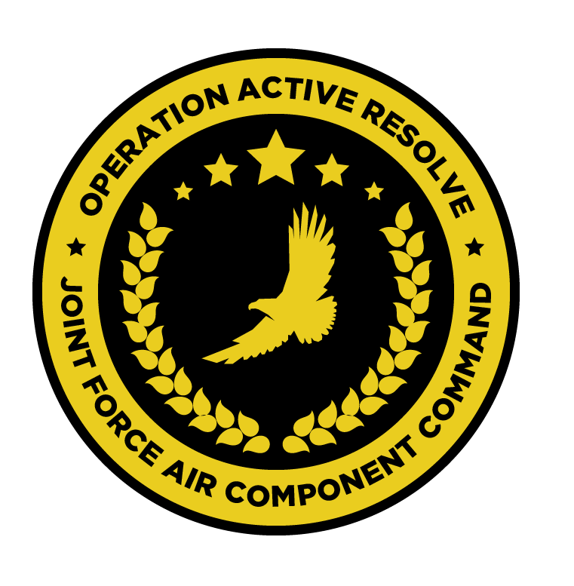

JFACC AIR OPERATIONS DIRECTIVE

OPERATION ACTIVE RESOLVE

D+1

# 1. SITUATION

## a. JFC guidance (verbatim).

See [CJTF Operations Order](https://132nd-vwing.github.io/OPAR-Brief/ORDERS/OPAR%20CJTF82%20OPERATION%20ORDER.pdf)

## b. Enemy situation.

See [VIS INTSUM D+1](https://132nd-vwing.github.io/OPAR-Brief/INTELLIGENCE/INTSUM/D1/VIS%20INTSUM%20D1%20Ground.pdf)

## c. Friendly situation (by joint force component).

See [CJTF Operations Order](https://132nd-vwing.github.io/OPAR-Brief/ORDERS/OPAR%20CJTF82%20OPERATION%20ORDER.pdf) and [LCC III Corps Conops](https://132nd-vwing.github.io/OPAR-Brief/ORDERS/OPAR%20LCC%20III%20CORPS%20CONCEPT%20OF%20OPERATIONS%20PHASE%201.pdf) and [LCC IV Corps Conops](https://132nd-vwing.github.io/OPAR-Brief/ORDERS/OPAR%20LCC%20IV%20CORPS%20CONCEPT%20OF%20OPERATIONS%20PHASE%201.pdf)

# 2. MISSION - The JFACC’s mission statement (verbatim).

JFACC will establish air superiority in the area of operations and defeat Syrian offensive capability in support of CJTF-82 offensive operations to neutralize Syrian offensive capability to conduct offensives in the region.

# 3. EXECUTION – AIR OPERATIONS

|  |  |
| --- | --- |
| **JFACC’s Intent**   1. **Purpose** 2. **End State** | JFACC’s intent is to provide airborne assets in order to achieve air superiority in Turkish and Isreali airspace, such that Syrian aggression into this airspace is prevented, ensuring the protection of ground forces from Syrian air attacks.  Further, it is intended that support be provided to friendly ground forces through the availability of air-to-ground strike aircraft, performing a variety of missions throughout the AO.  It is intended that such operations be complemented by a small number of Air Interdiction operations in order to meet strategic objectives as outlined by CJTF82.  The purpose of such operations is three-fold:   * To shape the AO . * To deny Syrian air forces the use of the air in order to aggress against friendly ground forces. * To provide direct support to friendly ground forces by attempting to attrit enemy ground forces.   The desired end state of these operations is one in which Syrian forces have been expelled from Turkey and Isreal, with respect to both ground and air forces. |
| **Execution** What to do, when. – Any detailed instructions if needed | In the execution of these missions, the AO is divided into two sectors – Sector NORTH and Sector SOUTH. These sectors are visible in the Airspace Control Plan ([ACP](https://132nd-vwing.github.io/OPAR-Brief/MISSION%20INFORMATION/AirspaceControlPlan.cf)).  Operations are to be conducted in both Sectors NORTH and SOUTH, in addition to AO operations in support of the destruction of targets from the JPTL.  Operations are to be supported by friend AWACS and Tanker support |
| **Focus of effort by objective** | Three areas of focus are addressed in this AOD:  **Sector NORTH**  In this sector, the majority of effort should be directed towards LCC IV Corps Objective BRAVO and the attrition of HQ assets in and around HATAY AIRFIELD and the area surrounding HATAY city.  Some focus should be directed towards LCC IV CORPS Objective ALPHA and the attrition of enemy ground forces, prioritising air defence assets, followed by the division of MBTs therein.  **Sector SOUTH**  Equal effort should be directed towards the attrition of LCC III Corps Objectives ALPHA and BRAVO. |
| **Allocation of sorties** (in percent) - CAS, AR, AI,DCA, OCA (SEAD is part of OCA) | **Sector NORTH – 40% Total**  50% - AI against LCC IV Corps Objective BRAVO  30% - AR against LCC IV Corps Objective ALPHA  20% - DCA in support of friendly forces  **Sector SOUTH – 40% Total**  40% - AR against LCC III Corps Objective ALPHA  40% - AR against LCC III Corps Objective BRAVO  20% - Joint DCA/SEAD operations in support of the sector  **STRIKE – 20% Total**  70% - AI against JTPL targets  30% - Escort of AI flights, should resources permit  **LOGISTICS**  100% of logistical operations should be directed towards the deployment of air defence assets in friendly airspace. |
| **Acceptable level of risk**. (including for AWACS and tankers: forward or rear) | Tolerance of risk should be minimal in the execution of these missions – ground forces are currently not engaged in conflict and there should be no desire to unnecessarily persecute enemy forces in the execution of these missions. |
| **Collateral damage and civilian casualty guidance** | Every attempt should be taken to minimise collateral damage in the execution of these missions. Civilian casualties should be avoided at all costs.  Suspected civilian casualties should be reported through the C2 network as soon as is practicable. |
| **TST guidance** | Should opportunities present, items from the TST matrix should be prosecuted. The outcome should be reported to the relevant C2 agency. |
| **Intelligence, Surveillance, Reconnaissance (ISR)** – If any effort should be done to support VIS with ISR to answer information gaps from VIS. | All notifications of enemy air defence assets – ground- and air-based – must be reported as soon as is practicable. Reports should, where possible, include the observing aircraft’s currently position, a relative bearing to the threat and the type of threat.  No specific ISR tasking are planned for this mission. |
| **Other issues** | N/A |
| **Direction and Guidance** | Aircrews must remain clear of Jordanian airspace at all times. Munitions must not be expended which may encroach on Jordanian airspace. |

# 4. ADMINISTRATION AND LOGISTICS

There are no known administrative or logistical considerations for these missions.

# 5. COMMAND AND CONTROL

There are no known, specific C2 considerations for these missions. Refer to the Command, Control and Communications section of the JAOP.